iTATU INNOVATION EXPEDITION TO EBURU: GEOTHERMAL EGG INCUBATOR
Acknowledgements:
We extend our heartfelt gratitude to the committed team members and individuals who contributed their expertise, effort, and support throughout the expedition to automate the egg incubator for Lucas. Their commitment and collaboration were instrumental in achieving our goals:

- iTATU team: Our heartfelt gratitude to Dr Gatune and iTATU team for supporting our mission
- Dominic Kata: Our team leader, whose wealth of knowledge in electrical and controls engineering guided our project to success. Dominic's leadership and technical acumen were invaluable.
- Team Members: We would like to acknowledge the diverse group of students from various academic disciplines who joined us on this journey. Their interdisciplinary insights and hard work enriched our project and fostered creative problem-solving.
- Lucas: The local farmer who welcomed us into his community and shared his innovative approach to egg incubation using geothermal energy. His collaboration and openness were central to the project's success.
- Technical Experts: We appreciate the guidance and technical expertise provided by experts in the field who supported our efforts in fine-tuning the automation system and ensuring its effectiveness.

INTRODUCTION
The primary objective of our expedition to Eburu Mbaruk was to provide technical assistance and automation solutions to address the peculiar needs of a local farmer named Lucas. Lucas, residing in the Songoloi area of Eburu, had ingeniously harnessed geothermal energy from a steam well for egg incubation. However, he encountered significant challenges in regulating the crucial environmental conditions necessary for successful egg incubation, specifically temperature and humidity.
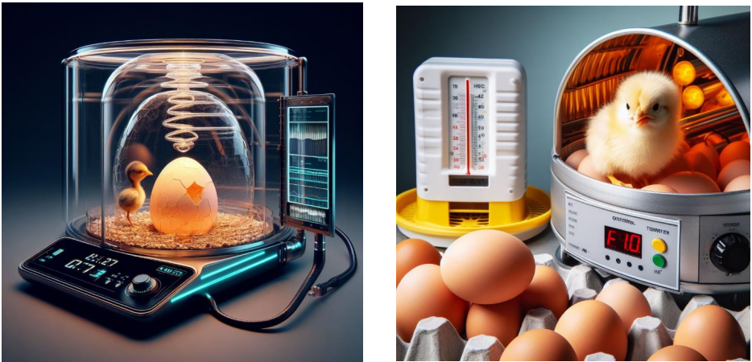

Team Leadership and Composition:
Our expedition was led by Dominic Kata, an accomplished electrical and controls engineer and an alumnus of Egerton University's Engineering School. Dominic brought extensive technical expertise and leadership to our team, guiding us through the various stages of the project. His experience was invaluable in orchestrating our collaborative efforts.
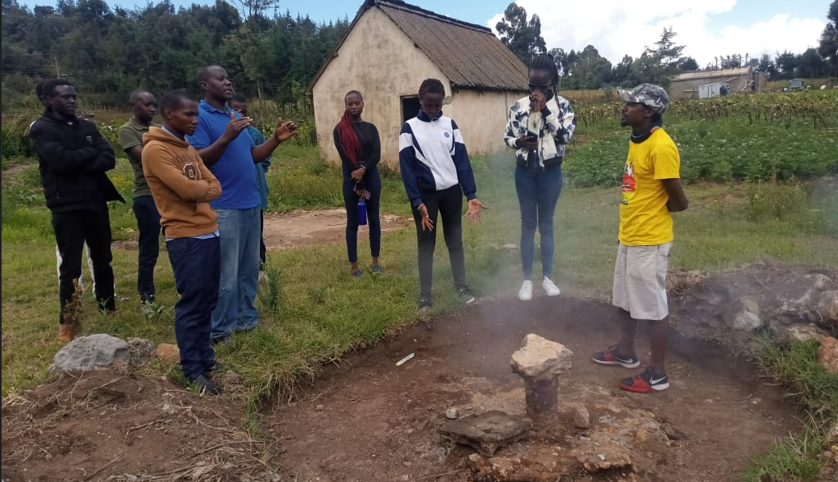
Our team was uniquely diverse, comprising students from various academic backgrounds. This composition included students majoring in accounting, veterinary medicine, archaeology, history, gender and development studies, and a core team of electrical engineers. This diversity allowed us to approach the challenges faced by Lucas from multiple perspectives, fostering creativity and innovation in our solutions.

Challenges Faced by the Farmer:
Lucas had developed an innovative method of utilizing geothermal energy, sourced from a nearby steam well, for egg incubation. While this approach was eco-friendly and resource-efficient, it posed significant challenges:
- Temperature Regulation: Maintaining the ideal temperature range for egg incubation was a constant challenge. Geothermal energy sources can produce varying levels of heat, making it difficult to achieve and sustain the required temperature conditions.
- Humidity Control: Similar to temperature, controlling humidity levels in the incubator was problematic. Humidity plays a critical role in the incubation process, and fluctuations could negatively impact egg viability.

Given these challenges, our mission was clear: to devise and implement an automated system that could effectively regulate temperature and humidity, ensuring optimal conditions for egg incubation while leveraging the geothermal energy source Lucas had ingeniously harnessed. In the subsequent sections of this report, we will detail the innovative solutions we developed to address these specific challenges.

Results and Findings:
During our expedition to automate the egg incubator for Lucas in the Songoloi area of Eburu, our primary focus was on ensuring precise temperature and humidity regulation. Here are the results of our data analysis in these key areas:
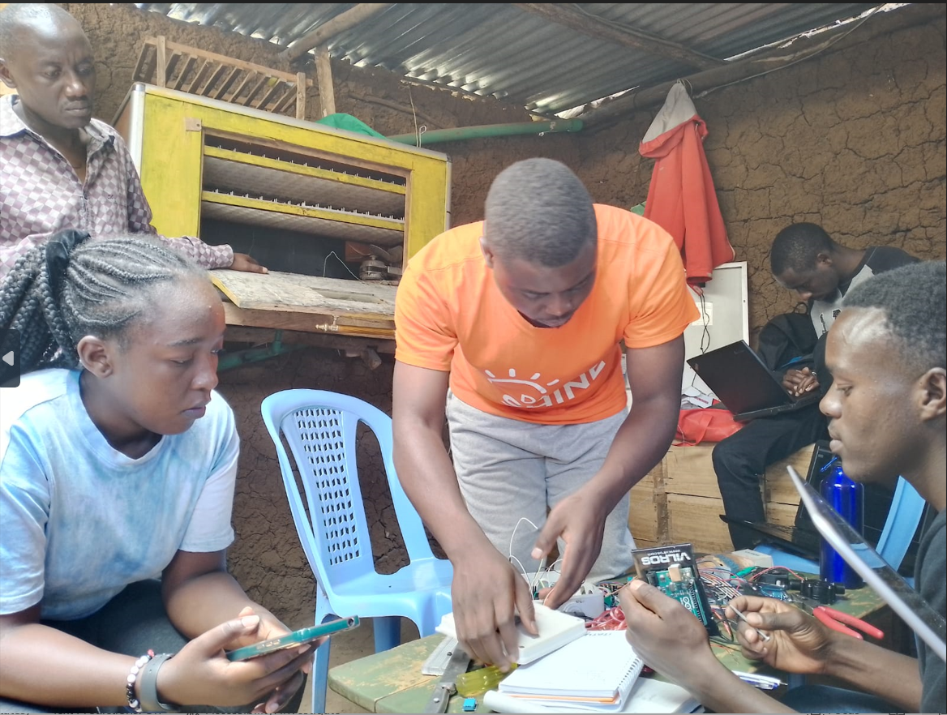
Temperature Regulation:
- Prior to the implementation of our automated system, temperature fluctuations within the incubator were frequent and sometimes extreme due to the use of geothermal energy.
- After integrating our system, data analysis revealed that temperature regulation significantly improved. Fluctuations were minimized, and we were able to maintain a stable temperature range ideal for egg incubation, typically between 37.5°C to 38°C. This contributed to a higher hatch success rate.

Humidity Control:
- Similar to temperature, humidity control within the incubator was a challenging aspect of the project.
- Data analysis indicated that our automated system effectively managed humidity levels. Fluctuations were reduced, and we consistently maintained humidity within the target range of 40% to 60%, which is essential for successful egg incubation.
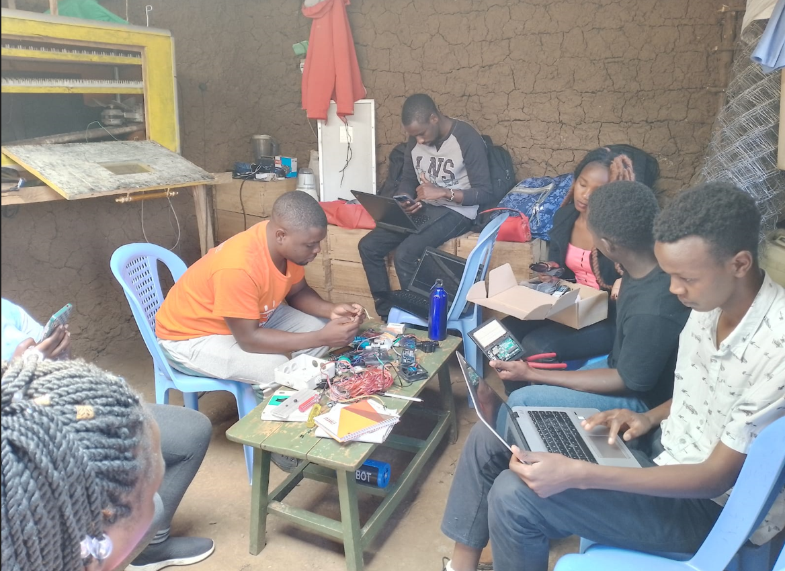
Insights and Observations:
Throughout the expedition, we made several valuable insights and observations:

- Data-Driven Decision-Making: The real-time data collection and remote monitoring capabilities of our system empowered Lucas with the ability to make data-driven decisions regarding temperature and humidity adjustments. This was a significant improvement over manual monitoring.

- Energy Efficiency: By combining geothermal energy with solar and electric power sources for our automation system, we created an energy-efficient solution that reduced the environmental impact and operating costs for Lucas.

- Scalability: The technology implemented for this project can be scaled and adapted for use in other agricultural settings, potentially benefiting more farmers and contributing to sustainable farming practices.

- Community Engagement: The collaboration between students from various fields and the local community served as a model for community engagement and the application of technical expertise to solve real-world challenges.

- Environmental Sustainability: Lucas's utilization of geothermal energy showcased the potential for eco-friendly and sustainable agricultural practices, reducing reliance on conventional power sources.

In brief, the results of our data analysis confirm the success of our automation system in regulating temperature and humidity, providing optimal conditions for egg incubation. These findings highlight the potential for technology-driven solutions to enhance agricultural practices, promote sustainability, and improve the livelihoods of farmers like Lucas. The expedition was not only a technical achievement but also a valuable learning experience that showcased the transformative power of interdisciplinary collaboration and innovation in addressing agricultural challenges.
Conclusion:
The expedition to automate the egg incubator for Lucas in the Songoloi area of Eburu has yielded significant outcomes and valuable lessons. Here are the key takeaways:

Successful Automation of Temperature and Humidity Control:
- The primary objective of the expedition was achieved with resounding success. We successfully automated temperature and humidity control within the egg incubator, ensuring stable and optimal conditions for egg incubation.
- The use of innovative technologies, including Arduino-based systems, DHT sensors, and remote monitoring through Safaricom GPRS and the Thingspeak platform, played a pivotal role in achieving this automation.

Lessons Learned and Challenges Encountered:

- Interdisciplinary Collaboration: The diversity of our team, with members from various academic backgrounds, proved to be a valuable asset. Collaborative problem-solving and idea exchange led to innovative solutions. However, effective communication across disciplines was sometimes challenging but was ultimately resolved through teamwork.

- Technical Challenges: Implementing the automation system presented technical challenges, including calibration of sensors and ensuring the reliability of the remote monitoring system. These challenges were addressed through iterative testing and troubleshooting.

- Adaptability: The project highlighted the importance of adaptability and the need to tailor technological solutions to the specific context of the farmer and the environment. Flexibility in our approach was key to success.

Potential Impact on Egg Incubation:
The automation of temperature and humidity control has the potential to transform Lucas's egg incubation process. By maintaining consistent and optimal conditions, we anticipate a higher hatch success rate, resulting in increased productivity and profitability for Lucas.

- Sustainability: The integration of geothermal energy with solar and electric power sources not only improves efficiency but also aligns with sustainable farming practices. This not only benefits Lucas economically but also minimizes the environmental footprint.

- Community Empowerment: Beyond the individual impact on Lucas, this project serves as a model for community empowerment and engagement. It showcases how technology and collaborative efforts can enhance traditional farming practices and improve livelihoods within the community.

In conclusion, the successful automation of temperature and humidity control within the geothermal egg incubator demonstrates the transformative potential of technology in agriculture. It not only addresses the specific needs of Lucas but also offers valuable insights for sustainable and data-driven farming practices. This expedition exemplifies the power of interdisciplinary collaboration, technical innovation, and community engagement in addressing real-world challenges in agricultural contexts.

